Ideation Phase
Brainstorm & Idea Prioritization Template

Date | 26 June2025
Team ID | LTVIP2025TMID34134
Project Name | Pollen's Profiling: Automated Classification of Pollen Grains
Maximum Marks | 4 Marks

Pollen's Profiling is a deep learning-based project designed to automate the classification of pollen grains using image processing and machine learning. The system uses Convolutional Neural Networks (CNNs) to classify pollen images based on morphological features such as shape, size, and texture.
Step-1: Team Gathering, Collaboration and Select the Problem Statement

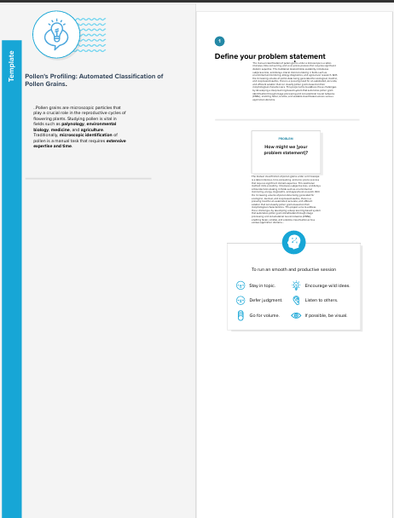

Step-2: Brainstorm, Idea Listing and Grouping
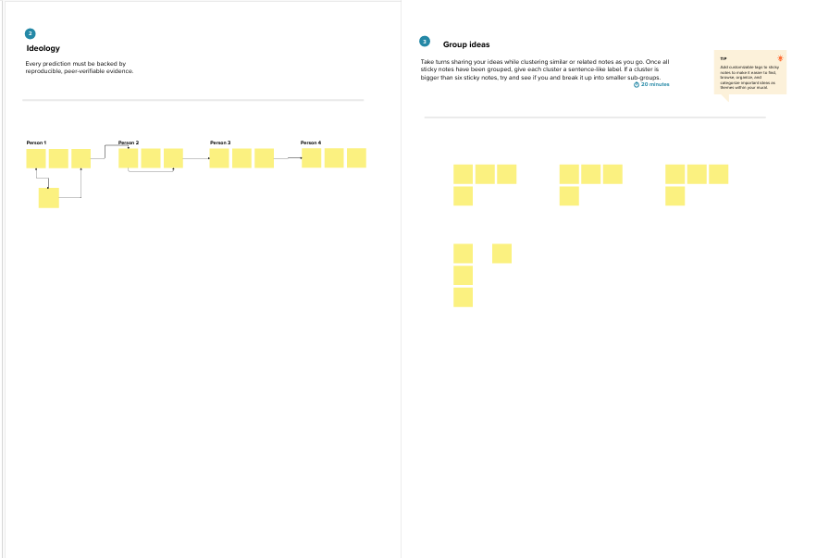

Step-3: Idea Prioritization
